Aleksas Murauskas

260718389

Question 1:

\

1. Using maximum likelihood estimation, estimate the observed conditional probabilities of disease given cautiousness: P(D=1|C=1) and P(D=1|C=0)

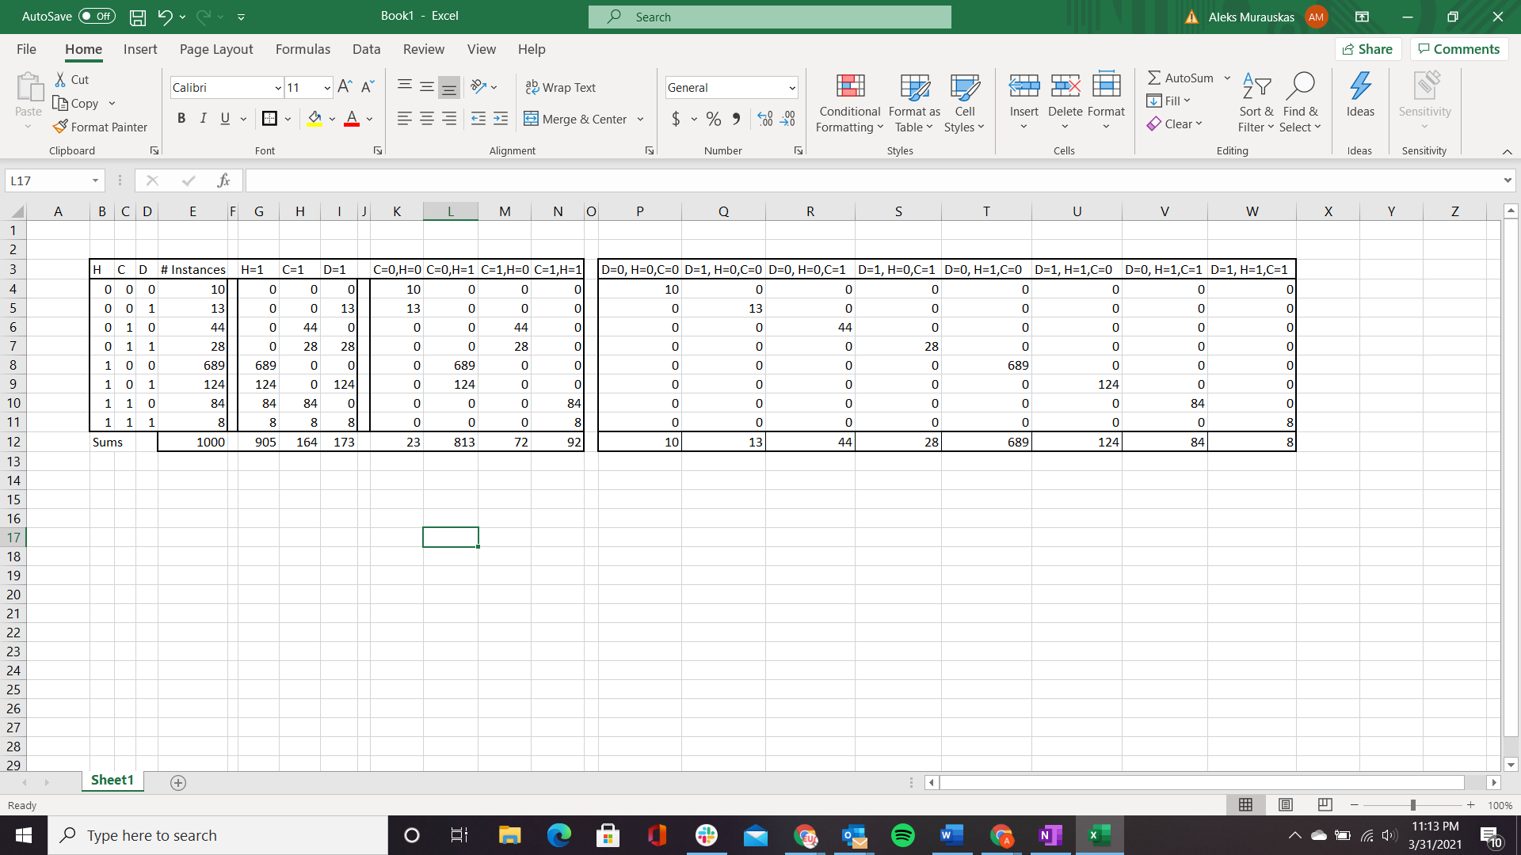



1. Suppose that we can intervene and perfectly persuade people to be cautious or not. Estimate P(D=1|do(C=1)) and P(D=1|do(C=0)) using maximum likelihood estimation. What is the relative risk reduction of adopting cautious behavior? (RRR = 1 – (P(D=1|do(C=1)) / P(D=1|do(C=0)))
2. A talk show host on TV points to your results in part a) to say that there is no point in being cautious. How do you rebut this argument?

This is incorrect, one must be careful of conflating causality and the conditional probabilities that are observable. Part a appears to imply that that you have a higher chance of contracting the disease if you are cautious. This is a correlation is spurious however, an apt comparison would be the relationship between a rainy day and people holding umbrellas. Probability of rain is higher if people are holding umbrellas, but the holding of umbrellas did not cause the clouds to rain. The results in part B display that being cautious does indeed decrease the likelihood of disease contraction.

Question 2

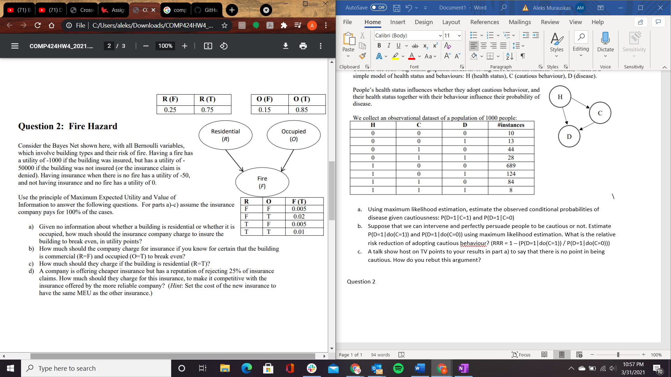

1. Given no information about whether a building is residential or whether it is occupied, how much should the insurance company charge to insure the building to break even, in utility points?
2. How much should the company charge for insurance if you know for certain that the building is commercial (R=F) and occupied (O=T) to break even?

Known R=F and O=T

1. How much should they charge if the building is residential (R=T)?

Only R=T is known

1. A company is offering cheaper insurance but has a reputation of rejecting 25% of insurance claims. How much should they charge for this insurance, to make it competitive with the insurance offered by the more reliable company? (Hint: Set the cost of the new insurance to have the same MEU as the other insurance.

Question 3:

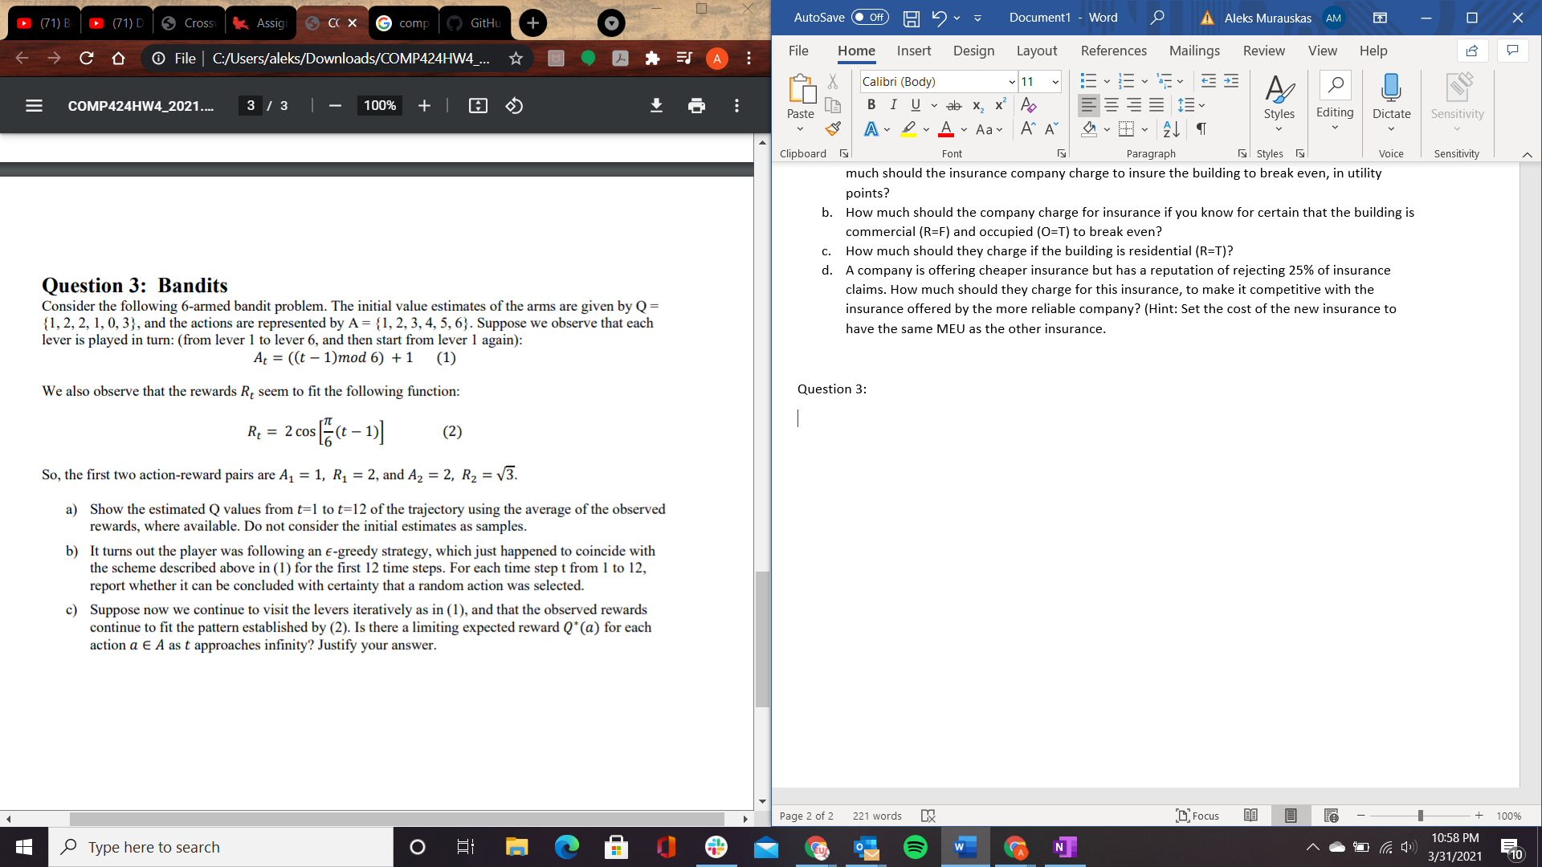

1. Show the estimated Q values from 𝑡=1 to 𝑡=12 of the trajectory using the average of the observed rewards, where available. Do not consider the initial estimates as samples.

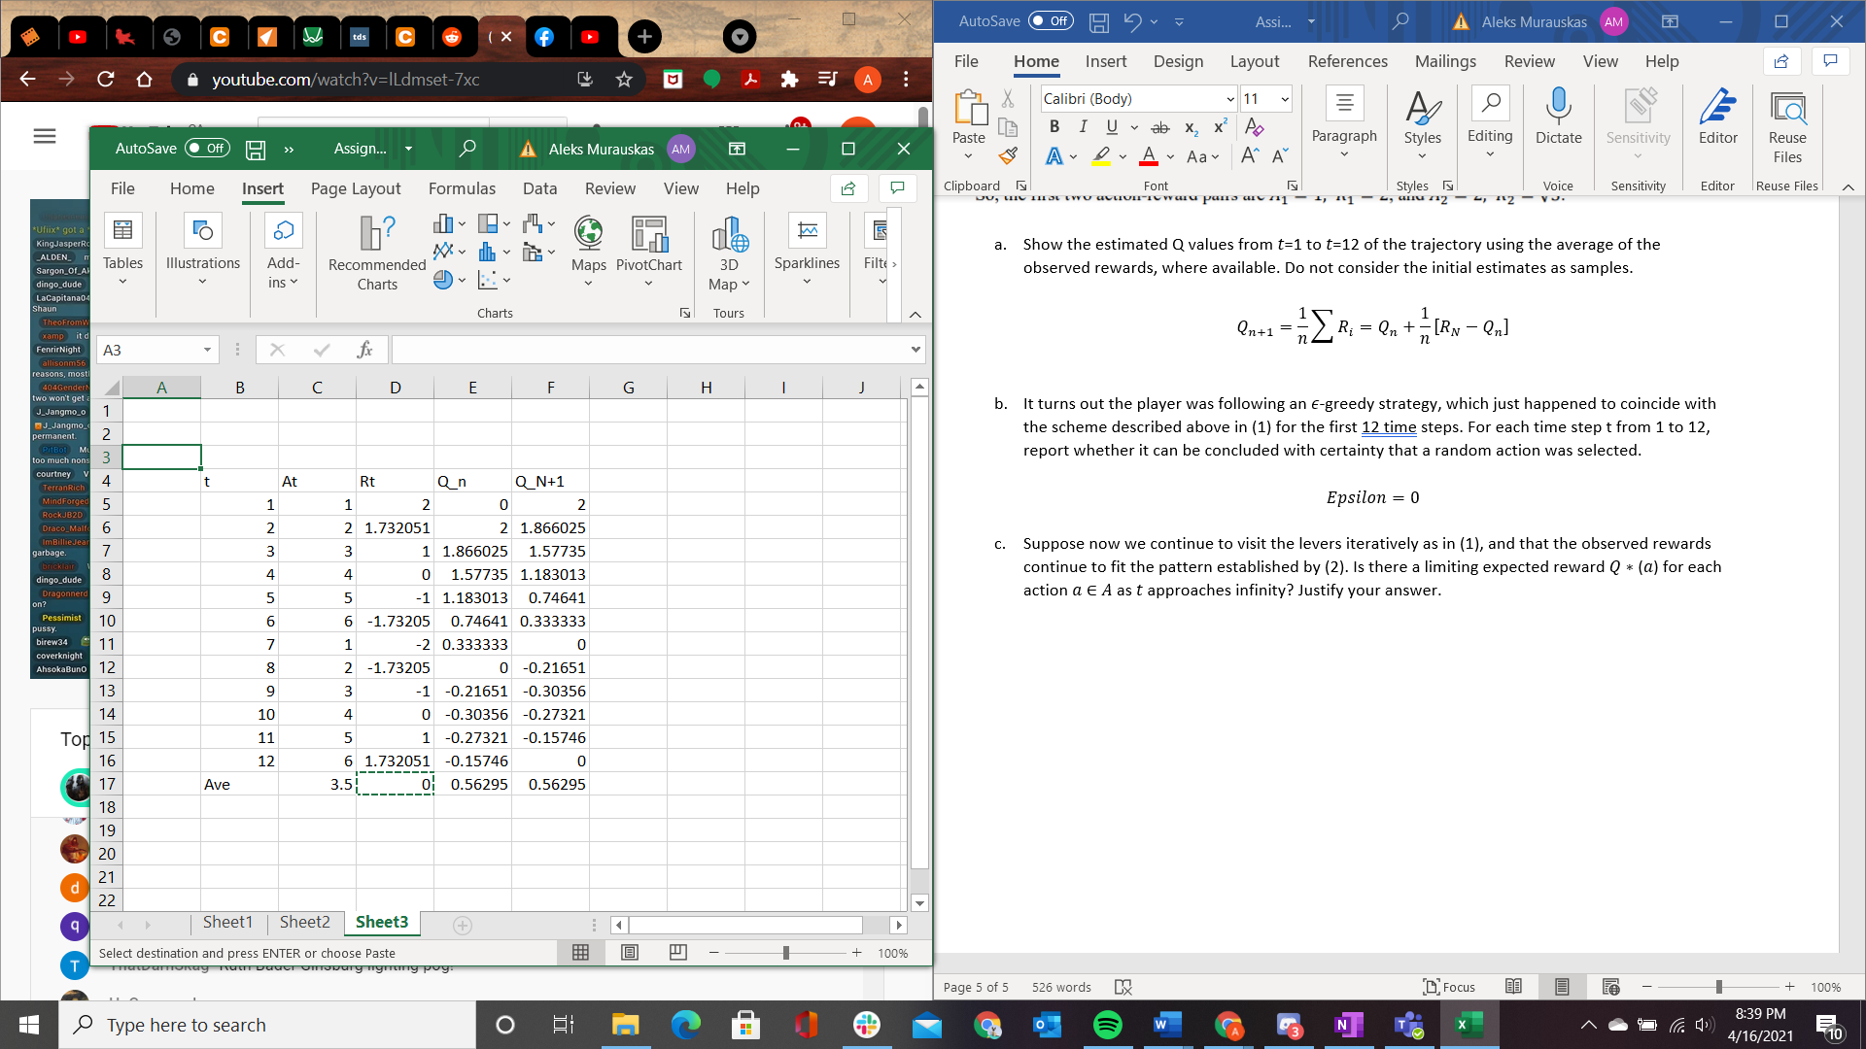

1. It turns out the player was following an 𝜖-greedy strategy, which just happened to coincide with the scheme described above in (1) for the first 12 time steps. For each time step t from 1 to 12, report whether it can be concluded with certainty that a random action was selected.
2. Suppose now we continue to visit the levers iteratively as in (1), and that the observed rewards continue to fit the pattern established by (2). Is there a limiting expected reward 𝑄 ∗ (𝑎) for each action 𝑎 ∈ 𝐴 as 𝑡 approaches infinity? Justify your answer.